**DAILY ONLINE ACTIVITIES SUMMARY**

|  |  |  |  |  |  |  |  |
| --- | --- | --- | --- | --- | --- | --- | --- |
| **Date:** | 29/05/2020 | | | | **Name:** | AMBIKA V | |
| **Sem & Sec** | 4th SEM SEC 'A' | | | | **USN:** | 4AL18CS005 | |
| **Online Test Summary** | | | | | | | |
| **Subject** | | Operating Systems(18CS43) | | | | | |
| **Max. Marks** | | 30 | | **Score** | | 29 | |
| **Certification Course Summary** | | | | | | | |
| **Course** | 1.Artificial intelligence in Python  2.Introduction to Ethical Hacking | | | | | | |
| **Certificate Provider** | | | Greatlearning Academy | **Duration** | | | 7hrs  6hrs |
| **Coding Challenges** | | | | | | | |
| **Problem Statement:** 1. Write a Java program to Find size of the largest ‘+’ formed by all ones in a binary matrix.  2. Write a C Program to generate first N Armstrong Numbers.  element. | | | | | | | |
| **Status:** Completed | | | | | | | |
| **Uploaded the report in Github** | | | | YES | | | |
| **If yes Repository name** | | | | https://github.com/ambika0202/lockdown-coding- | | | |
| **Uploaded the report in slack** | | | | YES | | | |

**Online Test Details:**

The online test was from module 2 which was about the Multi-threaded Programming, Process Synchronization. There were 30 questions and the duration was 45 minutes. The questions were optimal and were easy. The score that I got in the test is 29/30.

**Snapshot:**

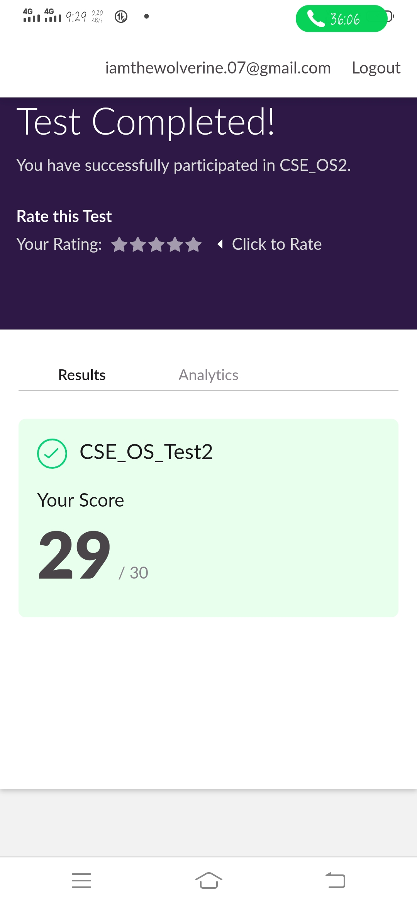

**Certification Course Details:**

**Name of the course**: Artificial intelligence in Python

**Certificate Provider**: Great Learning Academy

Python is a more popular language over C++ for AI and leads with a 57% vote among developers. That is because Python is easy to learn and implement. With its many libraries, they can also be used for data analysis. Performance wise C++ outperforms Python.

**Concepts :**

1. Agenda
2. History behind Neural Networks
3. Relationship between Biological Neuron and Artificial Neuron
4. Perceptron and Working Mechanism
5. Architecture of Artificial Neural Network
6. Types of Activation Function
7. Softmax Function
8. Forward Propagation
9. Loss Function
10. Demo Using Keras Framework
11. Back Propagation and gradient Descent
12. Tensorflow 2.0
13. Demo on Mnist Dataset

**Snapshot:**

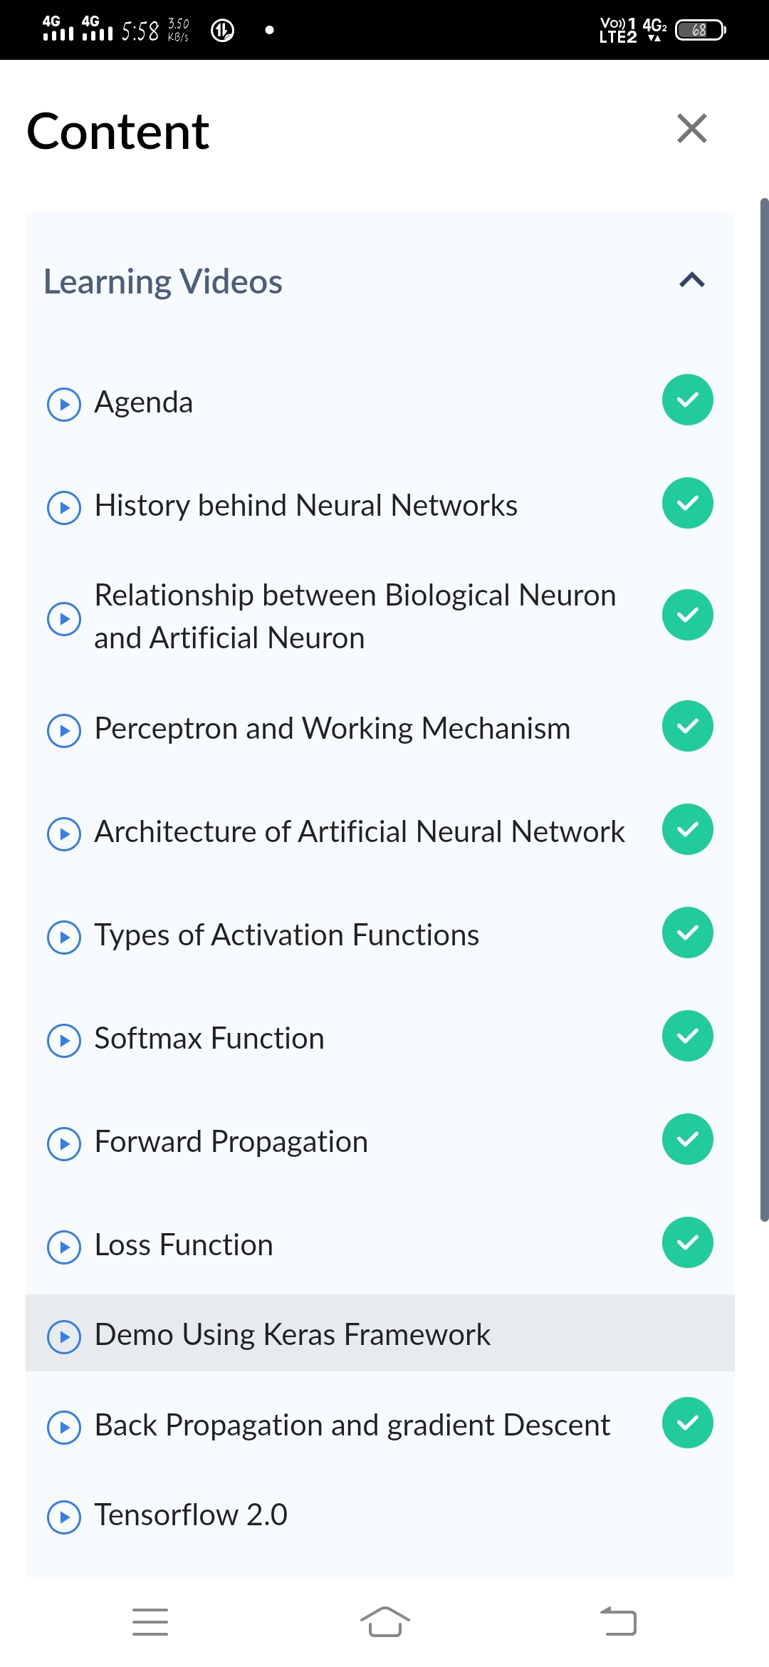

**Certification Course Details:**

**Name of the course**: Introduction to Ethical Hacking

**Certificate Provider**: Great Learning Academy

**Ethical Hacking**:

To crack passwords or to steal data? No, it is much more than that. Ethical hacking is to scan vulnerabilities and to find potential threats on a computer or networks. An ethical hacker finds the weak points or loopholes in a computer, web applications or network and reports them to the organization.

**Concepts:**

1. Career and Growth Ladder in Ethical Hacking
2. Domains and Process Implementation under Ethical Hacking
3. Ethical Hacking in Network Architecture-Demonstration
4. Ethical Hacking in Web Applications-Demonstration
5. Ethical Hacking on Mobile Platforms-Demonstration
6. What is Ethical Hacking

**Snapshot:**



**Online Coding Details:**

**Problem 1:** Write a Java program to Find size of the largest ‘+’ formed by all ones in a binary matrix.

**Snapshot:**

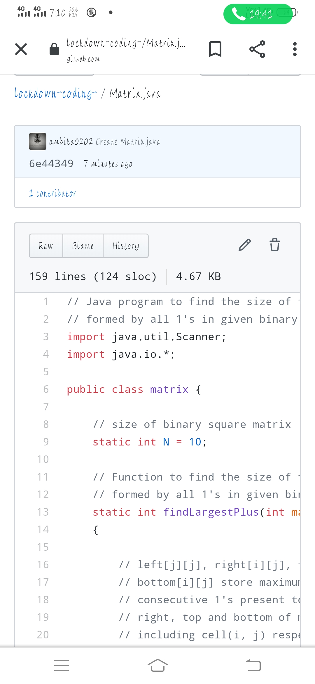

**Problem 2:** Write a C Program to generate first N Armstrong Numbers.

**Snapshot:**

